Here is a screenshot of the custom application build: halfway thru.

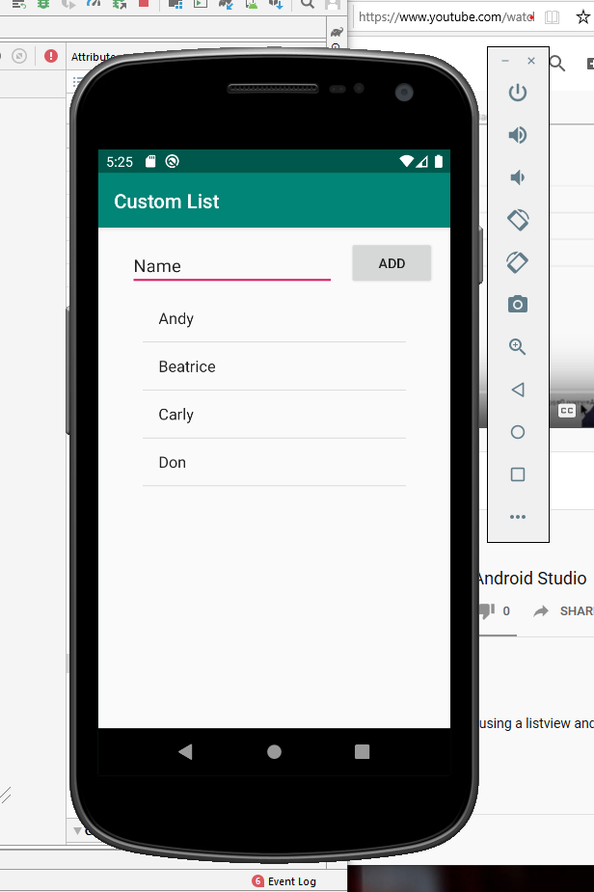

At the very end, I could not get my emulator to bring up my final product. It kept crashing. All of my code was good, no errors or code mistakes, the layout was in the proper order. But for some reason I could not get the emulator to load.